BACS2073 Software Design and Architecture Tutorial 7 Tutorial 7 – User Interface Design
1. Discuss user interface design principles.
2. What is the classification of user interaction styles?
3. Discuss three advantages of graphical information display and suggest three applications where it would be more appropriate to use graphical rather than digital displays of numeric information.
4. What are the guidelines that should be followed when using colours in a user interface? Suggest how colour might be used more effectively in the interface of a customer self-ordering system in a restaurant.
5. Suppose you are the online shoppers for lazada.com.my Online Shopping Portal System.
“The design of human-computer interaction for lazada.com is heavily influenced by non functional requirements.”
Do you agree with the above statement? Give TWO (2) reasons to explain your answer.
6. 2024 May/June (Past Exam)
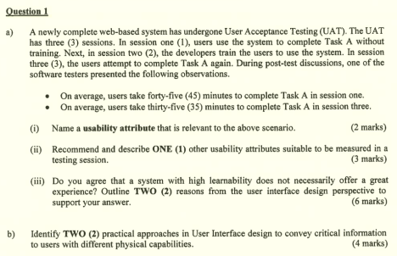Page 1 of 2
BACS2073 Software Design and Architecture Tutorial 7
Additional Questions
a) A development team is developing a system which is used for furniture design. The system should provide interface to the junior designer to draft and apply notation form the palette provided by system. Senior designer uses the system to fine tune the draft and instruct the system to perform necessary tasks with special instruction type into the system. They are less depending on the graphical interface.
(i) Suggestion TWO (2) user interaction styles for the above scenario. Provide justification for your suggestions. (6 marks)
(ii) Analyze TWO (2) challenges you may face when designing the interface for the above system. (4 marks)
(iii) Analyze TWO (2) usability attributes that are important for the system. (6 marks) (iv) Discuss TWO (2) ways of evaluating the system interface design. (4 marks)
Page 2 of 2

